SIMATS ENGINNERING

ARTIFICIAL INTELLIGENCE LAB OUTPUTS

DONE BY VIGNESH SH 192412046

- Simple Calculator Program
Aim: To write a Python program to perform basic arithmetic operations using a simple calculator.

Algorithm:

- Start the program.
- Get two numbers and an operator from the user.
- Perform the operation using if-elif.
- Display the result.
- Stop the program.

Code:

a = float(input("Enter first number:9"))

b = float(input("Enter second number:8")) op = input("Enter operator (+, -, *, /): ") if op == '+':
print("Result =", a + b) elif op == '-':
print("Result =", a - b) elif op == '*':
print("Result =", a * b) elif op == '/':
print("Result =", a / b) else:
print("Invalid operator")

Output:

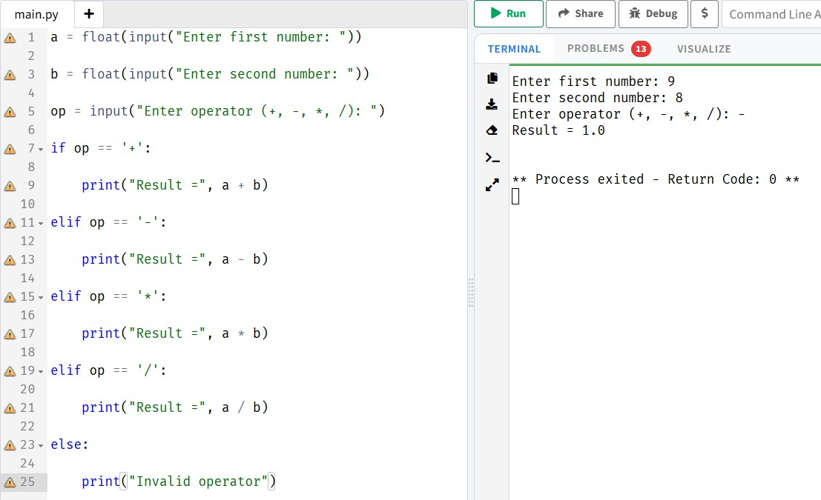

Add Two Matrices
Aim: To write a Python program to add two matrices. Algorithm:
- Start the program.
- Initialize two matrices.
- Add corresponding elements using nested loops.
- Display the resultant matrix.
- Stop the program.

Code:

a = | [[1, | 2], | [3, | 4]]
b = | [[5, | 6], | [7, | 8]]
c = | [[0, | 0], | [0, | 0]]

for i in range(2):

for j in range(2):

c[i][j] = a[i][j] + b[i][j] print("Sum of matrices:")
for row in c:

print(row)

Output:

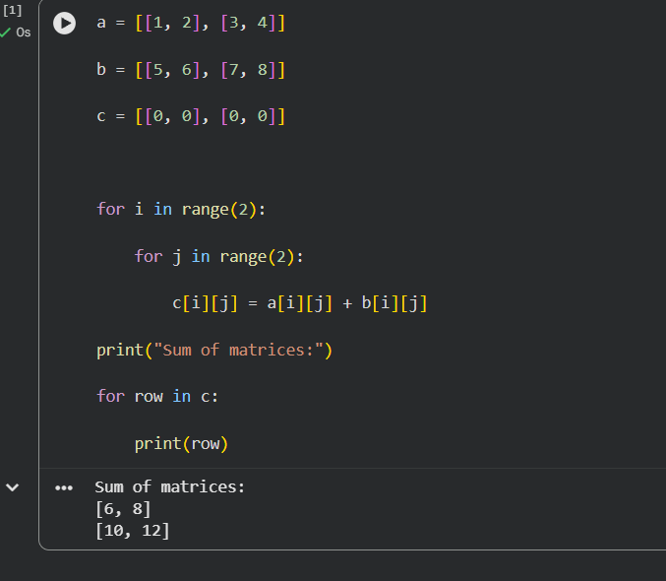

Transpose a Matrix
Aim: To write a Python program to find the transpose of a matrix. Algorithm:
- Start the program.
- Initialize a matrix.
- Exchange the rows and columns.
- Display the transposed matrix.
- Stop the program.

Code:

a = [[1, 2, 3], [4, 5, 6]]

print("Transpose:") for i in range(3):
for j in range(2): print(a[j][i], end=" ")
print()

Output:

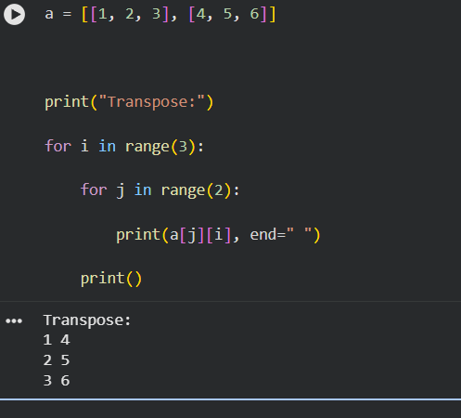

Sort a Sentence in Alphabetical Order
Aim: To write a Python program to sort the words in a sentence alphabetically. Algorithm:
- Start the program.
- Get a sentence from the user.
- Split the sentence into words.
- Sort the words alphabetically.
- Display the sorted sentence.
- Stop the program.

Code:

s = input("Enter a sentence: ") words = s.split()
words.sort()

print("Sorted sentence:", " ".join(words))

Output:
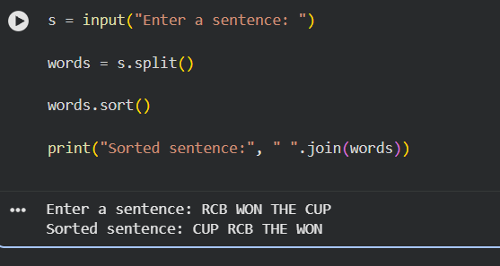

Implement List Operations
Aim: To write a Python program to perform list operations such as nested list, length, concatenation, membership, iteration, indexing and slicing.

Algorithm:

- Start the program.
- Create a list of elements.
- Perform the required list operations.
- Display the results.
- Stop the program.

Code:

a = [10, 20, 30, 40]

print("List:", a)

print("Nested List:", [a, [50, 60]]) print("Length:", len(a)) print("Concatenation:", a + [50, 60]) print("Membership:", 20 in a) print("Iteration:")
for i in a:

print(i) print("Indexing:", a[1])
print("Slicing:", a[1:3])

Output:
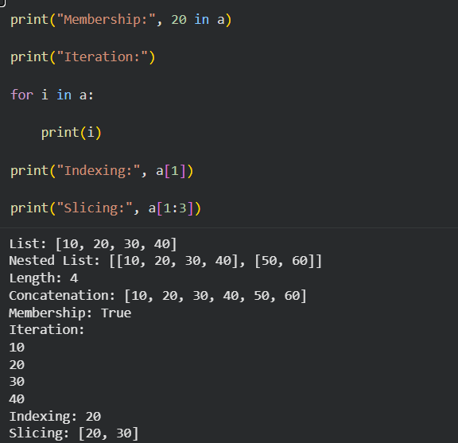

Python Program to Implement List Methods (Add, Append, Extend and Delete)
Aim: To write a Python program to demonstrate list methods such as adding, appending, extending and deleting elements.

Algorithm:

- Create a list.
- Add and append elements to the list.
- Extend the list with another list.
- Delete an element.
- Display the results.

Code:

a = [10, 20, 30]

print("Original List:", a) a.insert(1, 15) print("Add:", a) a.append(40) print("Append:", a)
a.extend([50, 60])

print("Extend:", a) del a[0] print("Delete:", a) Output:

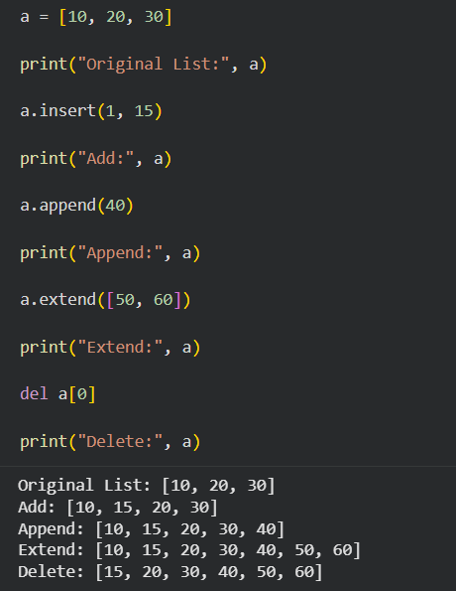

Python Program to Illustrate Different Set Operations
Aim: To write a Python program to perform set operations such as union, intersection, difference and symmetric difference.

Algorithm:

  - Create two sets.
  - Perform union and intersection.
  - Perform difference and symmetric difference.
  - Display the results.

Code:

a = {1, 2, 3, 4}

b = {3, 4, 5, 6}

print("Union:", a | b) print("Intersection:", a & b) print("Difference:", a - b) print("Symmetric Difference:", a ^ b)
Output:
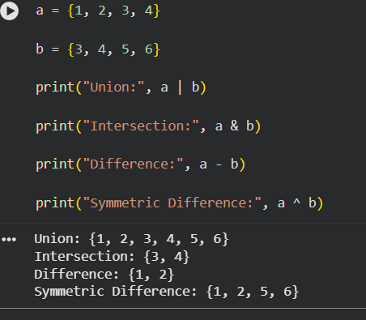

Python Program to Generate Calendar for the Given Month and Year
Aim: To write a Python program to display the calendar for a given month and year. Algorithm:
  - Import the calendar module.
  - Get the month and year from the user.
  - Generate the calendar.
  - Display the calendar.

Code:

import calendar

year = int(input("Enter year: ")) month = int(input("Enter month: ")) print(calendar.month(year, month))
Output:
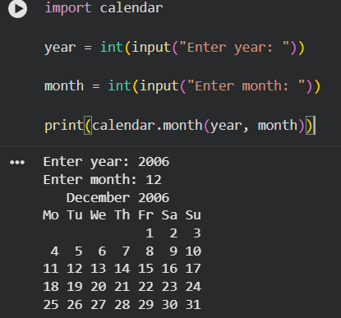

Python Program to Remove Punctuations from a Given String
Aim: To write a Python program to remove punctuation marks from a given string. Algorithm:
  - Get a string from the user.
  - Create a string containing punctuation marks.
  - Check each character.
  - Remove punctuation marks.
  - Display the result.

Code:

import string

s = input("Enter a string: ") result = ""
for ch in s:

if ch not in string.punctuation: result += ch
print("String without punctuation:", result)

Output:

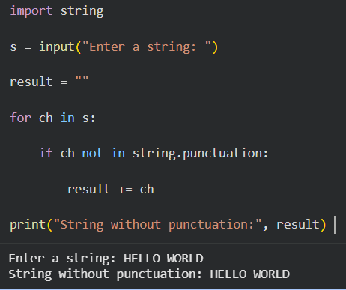

Python Program to Solve the 8-Puzzle Problem
Aim: To write a Python program to solve the 8-puzzle problem using the A* search algorithm. Algorithm:
- Define the initial and goal states.
- Calculate the Manhattan distance heuristic.
- Select the state with the lowest cost.
- Generate possible moves of the blank tile.
- Repeat until the goal state is reached.
- Display the solution steps.

Code:

from heapq import heappush, heappop start = (1, 2, 3, 4, 0, 6, 7, 5, 8)
goal = (1, 2, 3, 4, 5, 6, 7, 8, 0)

def h(s):

d = 0

for i in range(9): if s[i] != 0:
g = s[i] - 1

d += abs(i // 3 - g // 3) d += abs(i % 3 - g % 3)
return d

q = [(h(start), 0, start, [])] seen = set()
while q:

f, cost, s, path = heappop(q) if s in seen:

continue seen.add(s) if s == goal:
for state in path + [s]: print(state[:3]) print(state[3:6]) print(state[6:]) print()
break

z = s.index(0)

r, c = divmod(z, 3)

for dr, dc in [(1, 0), (-1, 0), (0, 1), (0, -1)]:

nr, nc = r + dr, c + dc

if 0 <= nr < 3 and 0 <= nc < 3: nz = nr * 3 + nc
t = list(s)

t[z], t[nz] = t[nz], t[z] t = tuple(t)
if t not in seen:

heappush(q, (cost + 1 + h(t),

cost + 1, t, path + [s]))

Output:

